OS Lab Assignment 6

## Name: Keshav Garg

## ID: 2018UCP1674

GitHub repo link: [**Here**](https://github.com/gargk747/OS-Lab/tree/master/Assignment%206)

1. **Producer-Consumer:**

Two Process-

**Producer.c**

#include <sys/types.h>

#include <sys/ipc.h>

#include <sys/shm.h>

#include <stdio.h>

#include <stdlib.h>

#include <unistd.h>

#include <time.h>

#include <stdbool.h>

#define BUFFERSIZE 10

typedef struct {

bool read;

int buffer[BUFFERSIZE];

} shm_struct;

int main(int argc, char* argv[])

{

int shmid;

key_t key;

shm_struct * shm;

int rand_num;

FILE *fp; //file object

//create a producer txt file

fp = fopen("producer.txt", "w+");

srand(time(NULL)); // should only be called once

if ((shmid = shmget(key, sizeof(shm_struct), IPC_CREAT | 0666)) < 0) {

perror("shmget");

exit(1);

}

if ((shm = shmat(shmid, NULL, 0)) == (shm_struct *) -1) {

perror("shmat");

exit(1);

}

shm->read = true;

//pushing values

for (int j=0; j<100; j++) //100x 10 = 1000 elements

{

while(shm->read); //wait for consumer to read

if (!shm->read) //if consumer has read, produce.

{

for (int i=0; i<10; i++)

{

rand_num = rand() % 100; //generate random numbers

shm->buffer[i] = rand_num;//store to array

fprintf(fp, "%d \n",rand_num);//store to file

}

shm->read = true;// allow consumer to read

}

}

//destroy shared memory

shmdt (shm);

shmctl (shmid, IPC_RMID, NULL);

//close file

fclose(fp);

exit(0);

}

**Consumer.c**

#include <sys/types.h>

#include <sys/ipc.h>

#include <sys/shm.h>

#include <stdio.h>

#include <stdlib.h>

#include <unistd.h>

#include <stdbool.h>

#define BUFFERSIZE 10

typedef struct {

bool read;//if the consumer should read or not

int buffer[BUFFERSIZE];

} shm_struct;

int main(int argc, char* argv[])

{

int shmid;

key_t key;

shm_struct *shm;

FILE *fp; //file object

//open file

fp = fopen("consumer.txt", "w+");

/*

* We need to get the segment named

* "5678", created by the server.

*/

key = 5671;

/*

* Locate the segment.

*/

if ((shmid = shmget(key, sizeof(shm_struct), 0666)) < 0) {

perror("shmget");

exit(1);

}

/*

* Now we attach the segment to our data space.

*/

if ((shm = shmat(shmid, NULL, 0)) == (shm_struct *) -1) {

perror("shmat");

exit(1);

}

/*

* Now read what the server put in the memory.

*/

shm->read=false;// have read now

for (int j=0; j<100; j++)//100 x 10 = 1000 elements

{

while (!shm->read); //wait for it to producer to write

if (shm->read) //read now

{

for (int i=0; i<10; i++){

fprintf(fp, "%d \n",shm->buffer[i]);//save to file

}

shm->read = false;// have read now

}

}

/*

* cleanup: detach shm

*/

shmdt (shm);

//close file

fclose(fp);

exit(0);

}

Two Thread-

#include <stdio.h>

#include <stdlib.h>

#include <pthread.h>

#include <time.h>

#include <stdbool.h>

// Let us create a global queue to change it in threads

int mesg_text[10];//queue size

bool read = false;// if the consumer should read or not

// The function to be executed by producer thread

void *producer()

{

int queue_index_p = 0;

int rand_num;

int total_num_sent = 0;

FILE *fp; //file object- producer

//create a producer txt file

fp = fopen("producer.txt", "w+");

while(total_num_sent!=1000)//for all 1000 values

{

while(read);

// random number generate

rand_num = rand() % 100;

//storing number in array of lenght 10

mesg_text[queue_index_p] = rand_num;

fprintf(fp, "%d \n",rand_num);//storing in file

queue_index_p++;

total_num_sent++;

if (queue_index_p==10)

{

queue_index_p =0;

read = true;//consumer can read now

}

}

//close file

fclose(fp);

}

// The function to be executed by consumer thread

void *consumer()

{

int queue_index_c = 0;

int total_num_recvd = 0;

FILE *fc; //file object- consumer

//create a consumer txt file

fc = fopen("consumer.txt", "w+");

while(total_num_recvd<1000)

{

while(!read);

//storing number in file

fprintf(fc, "%d \n",mesg_text[queue_index_c]);

queue_index_c++;

total_num_recvd++;

if (queue_index_c==10)

{

queue_index_c =0;

read = false;// the producer can produce now

}

}

//close file

fclose(fc);

}

int main()

{

//create thread id

pthread_t tid;

srand(time(NULL)); // should only be called once

//create two threads

//producer thread

pthread_create(&tid, NULL, producer, NULL);

//consumer thread

pthread_create(&tid, NULL, consumer, NULL);

//destroy all threads

pthread_exit(NULL);

return 0;

}

1. **Reader-Writer:**

RW1-

#include<stdio.h>

#include<pthread.h>

#include<semaphore.h>

#include<stdlib.h>

#include<unistd.h>

sem_t lock,resource;

int arr[10];

int count = 0;

void* writer(void* num){

int k = (int)num;

sem_wait(&resource);

printf("Writer %d is writing\n",k);

sleep(2);

for(int i=0;i<10;i++){

arr[i] = rand()%50;

}

printf("Reader count = %d\n",count);

sem_post(&resource);

}

void* reader(void* num){

int k = (int)num;

sem_wait(&lock);

count++;

if(count == 1){

sem_wait(&resource);

}

printf("Reader %d is reading\n",k);

printf("Reader count = %d\n",count);

sem_post(&lock);

//cs

sleep(2);

sem_wait(&lock);

count--;

if(count==0){

sem_post(&resource);

}

sem_post(&lock);

}

int main(){

sem_init(&resource,0,1);

sem_init(&lock,0,1);

pthread_t w[5],r[5];

for(int i=0;i<5;i++){

pthread_create(&w[i],NULL,&writer,(void*)((int)(i+1)));

pthread_create(&r[i],NULL,&reader,(void*)((int)(i+1)));

}

for(int i=0;i<5;i++){

pthread_join(w[i],NULL);

pthread_join(r[i],NULL);

}

return 0;

}

**Output:**

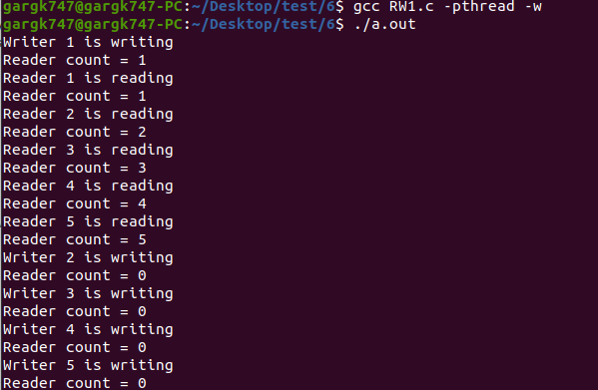

RW2-

#include<stdio.h>

#include<pthread.h>

#include<semaphore.h>

#include<stdlib.h>

#include<unistd.h>

sem_t rlock,wlock,readTry,resource;

int rcount=0,wcount=0;

void* writer(void* num){

while(1){

int k = (int)num;

sem_wait(&wlock);

wcount++;

if(wcount == 1){

sem_wait(&readTry);

}

sem_post(&wlock);

sem_wait(&resource);

printf("Writer %d is writing\n",k);

printf("Readers = %d and Writers = %d\n",rcount,wcount);

sem_post(&resource);

sem_wait(&wlock);

wcount--;

if(wcount==0){

sem_post(&readTry);

}

sem_post(&wlock);

sleep(1);

}

}

void* reader(void* num){

while(1){

int k = (int)num;

sem_wait(&readTry);

sem_wait(&rlock);

rcount++;

if(rcount==1){

sem_wait(&resource);

}

sem_post(&rlock);

sem_post(&readTry);

printf("Reader %d is reading\n",k);

printf("Readers = %d and Writers = %d\n",rcount,wcount);

sem_wait(&rlock);

rcount--;

if(rcount==0){

sem_post(&resource);

}

sem_post(&rlock);

sleep(1);

}

}

int main(){

sem_init(&rlock,0,1);

sem_init(&wlock,0,1);

sem_init(&resource,0,1);

sem_init(&readTry,0,1);

pthread_t w[5],r[5];

for(int i=0;i<5;i++){

pthread_create(&w[i],NULL,&writer,(void*)((int)(i+1)));

pthread_create(&r[i],NULL,&reader,(void*)((int)(i+1)));

}

for(int i=0;i<5;i++){

pthread_join(w[i],NULL);

pthread_join(r[i],NULL);

}

return 0;

}

**Output:**

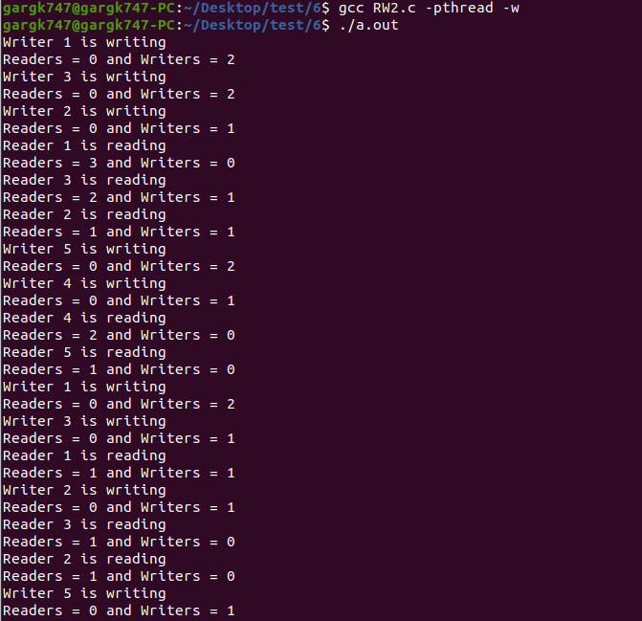

RW3-

#include<stdio.h>

#include<pthread.h>

#include<semaphore.h>

#include<stdlib.h>

#include<unistd.h>

sem_t resource,readCount,service;

int count=0;

void* writer(void* num){

while(1){

int k = (int)num;

sem_wait(&service);

sem_wait(&resource);

sem_post(&service);

printf("Writer %d is writing\n",k);

printf("Number of readers = %d\n",count);

sem_post(&resource);

sleep(1);

}

}

void* reader(void* num){

while(1){

int k = (int)num;

sem_wait(&service);

sem_wait(&readCount);

if(count==0){

sem_wait(&resource);

}

count++;

sem_post(&service);

sem_post(&readCount);

printf("Reader %d is reading\n",k);

printf("Number of readers = %d\n",count);

sem_wait(&readCount);

count--;

if(count==0){

sem_post(&resource);

}

sem_post(&readCount);

sleep(1);

}

}

int main(){

sem_init(&resource,0,1);

sem_init(&readCount,0,1);

sem_init(&service,0,1);

pthread_t w[5],r[5];

for(int i=0;i<5;i++){

pthread_create(&w[i],NULL,&writer,(void*)((int)(i+1)));

pthread_create(&r[i],NULL,&reader,(void*)((int)(i+1)));

}

for(int i=0;i<5;i++){

pthread_join(w[i],NULL);

pthread_join(r[i],NULL);

}

return 0;

}

**Output:**

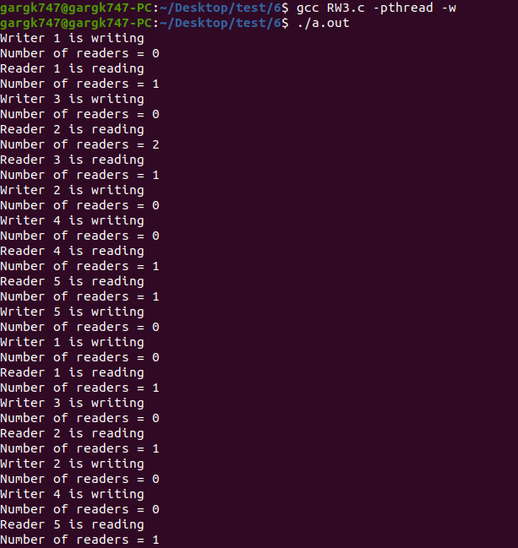

1. **Dining Philosopher:**

#include <pthread.h>

#include <stdio.h>

#include <unistd.h>

#include <time.h>

#include <stdlib.h>

#define NUMBER_OF_PHILOSOPHERS 5

void *philosopher(void *);

void think(int);

void pickUp(int);

void eat(int);

void putDown(int);

pthread_mutex_t chopsticks[NUMBER_OF_PHILOSOPHERS];

pthread_t philosophers[NUMBER_OF_PHILOSOPHERS];

pthread_attr_t attributes[NUMBER_OF_PHILOSOPHERS];

int main() {

int i;

srand(time(NULL));

for (i = 0; i < NUMBER_OF_PHILOSOPHERS; ++i) {

pthread_mutex_init(&chopsticks[i], NULL);

}

for (i = 0; i < NUMBER_OF_PHILOSOPHERS; ++i) {

pthread_attr_init(&attributes[i]);

}

for (i = 0; i < NUMBER_OF_PHILOSOPHERS; ++i) {

pthread_create(&philosophers[i], &attributes[i], philosopher, (void *)(i));

}

for (i = 0; i < NUMBER_OF_PHILOSOPHERS; ++i) {

pthread_join(philosophers[i], NULL);

}

return 0;

}

void *philosopher(void *philosopherNumber) {

while (1) {

think(philosopherNumber);

pickUp(philosopherNumber);

eat(philosopherNumber);

putDown(philosopherNumber);

}

}

void think(int philosopherNumber) {

int sleepTime = rand() % 3 + 1;

printf("Philosopher %d will think for %d seconds\n", philosopherNumber, sleepTime);

sleep(sleepTime);

}

void pickUp(int philosopherNumber) {

int right = (philosopherNumber + 1) % NUMBER_OF_PHILOSOPHERS;

int left = (philosopherNumber + NUMBER_OF_PHILOSOPHERS) % NUMBER_OF_PHILOSOPHERS;

if (philosopherNumber & 1) {

printf("Philosopher %d is waiting to pick up chopstick %d\n", philosopherNumber, right);

pthread_mutex_lock(&chopsticks[right]);

printf("Philosopher %d picked up chopstick %d\n", philosopherNumber, right);

printf("Philosopher %d is waiting to pick up chopstick %d\n", philosopherNumber, left);

pthread_mutex_lock(&chopsticks[left]);

printf("Philosopher %d picked up chopstick %d\n", philosopherNumber, left);

}

else {

printf("Philosopher %d is waiting to pick up chopstick %d\n", philosopherNumber, left);

pthread_mutex_lock(&chopsticks[left]);

printf("Philosopher %d picked up chopstick %d\n", philosopherNumber, left);

printf("Philosopher %d is waiting to pick up chopstick %d\n", philosopherNumber, right);

pthread_mutex_lock(&chopsticks[right]);

printf("Philosopher %d picked up chopstick %d\n", philosopherNumber, right);

}

}

void eat(int philosopherNumber) {

int eatTime = rand() % 3 + 1;

printf("Philosopher %d will eat for %d seconds\n", philosopherNumber, eatTime);

sleep(eatTime);

}

void putDown(int philosopherNumber) {

printf("Philosopher %d will will put down her chopsticks\n", philosopherNumber);

pthread_mutex_unlock(&chopsticks[(philosopherNumber + 1) % NUMBER_OF_PHILOSOPHERS]);

pthread_mutex_unlock(&chopsticks[(philosopherNumber + NUMBER_OF_PHILOSOPHERS) % NUMBER_OF_PHILOSOPHERS]);

}

**Output:**

